
AAUW Fredericksburg (VA) Area Branch
The Virginia General Election in November 2025
Saturday, November 15, 2025, at 2:00 PM
Location: University of Mary Washington, Combs Hall, Room 139, located on College Avenue near William Street. Free parking is available on College Avenue. Visitor spaces are located on Double Drive immediately upon entering the University’s gates off College Avenue. The building is fully accessible using a ramp on the campus side of the building.
In this presentation, Dr. Stephen Farnsworth will examine the dynamics of the 2025 election for governor and other leaders in Virginia. He will discuss the impact of the current national scene on the voting patterns in the Commonwealth.
Dr. Farnsworth’s political commentary has appeared in a wide range of media outlets, including the New York Times, Washington Post, Wall Street Journal, PBS NewsHour, and BBC World. We welcome Dr. Farnsworth back to AAUW Fredericksburg Area Branch to share his thoughts on the 2025 election in Virginia.
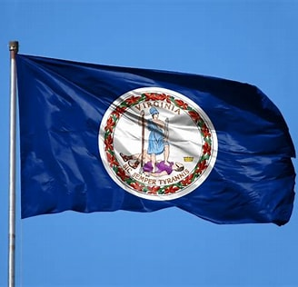

OUR SPEAKER
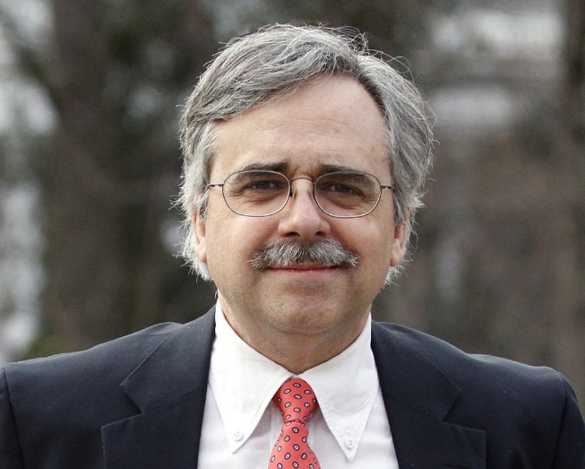
Stephen J. Farnsworth, PhD, is Professor of Political Science and International Affairs and Director of the Center for Leadership and Media Studies at the University of Mary Washington. He is the author or co-author of nine books on the presidency, the mass media, public opinion and journalism. He also has received the Virginia Outstanding Faculty Award from the State Council of Higher Education for Virginia and is the recipient of three campus-wide teaching awards at UMW. Dr. Farnsworth received a Ph.D. and an M.A. in government from Georgetown University, a B.A. in history from the University of Missouri-Kansas City, and a B.A. in government from Dartmouth College.

e
Books authored by Stephen Farnsworth will be available for purchase prior to the meeting outside the meeting room in Combs Hall. Dr. Farnsworth will autograph books that attendees bring or purchase at the meeting.
The meeting is free and open to the public.

